**COMM5961A Assignment_3**

**Problem Set**

**Name:** Kwan, Tsz Mei **Student ID:** 1155161658

**Introduction**

As a lover of shopping centers and an intern who used to be worked in the digital transformation project of commercial real estate business, I realized the information about shopping including the promotions, branding campaigns or store locations, etc is fragmented and disorganized across multiple channels, or primarily based on the opinions of netizens on various SNS. Especially in Hong Kong, we have well-developed online services for restaurant seeking, lodging reservation and car-hailing service such as ‘OpenRice’, ‘Uber’, ‘ Airbub’ and ‘Trivago’, but what about an application or a website for shopping-lovers?

While shopping is a kind of basic necessity in life, I believe there is a vacancy and demand. To

improve the shopping experience in Hong Kong, I want to establish a website that focuses on giving timely and comprehensive shopping information.

**Interview**

1. A list of interview questions

Preliminary investigation:

1. Which malls/brands do you usually go to for offline shopping? Shopping frequency? Consumption habits?
2. What is your general offline shopping mode? (e.g. Purposeful, casual, entertaining)
3. Which websites or information sources will you rely on to obtain shopping center/offline brands or product related information?

User experience analysis:

1. How would you find the shopping center/brand store/product you need to go to?
2. How would you choose your destination?
3. How would you record/save the information of the mall/shop you need to go to? (e.g. map/business hours, etc.)
4. What functions do you generally use? (Is the presentation of each function clear? How does it feel to use?)
5. Does it have a community sharing function? (Does it have other users’ comments/pictures? Will you refer to their content? Will you place your own content? Why?)
6. What part could be improved and how?
7. What content should be added?
8. Is this website helpful if you are going to shop in Hong Kong?
9. Interviewees

The requirement of interviewees selection:

1. Had shopping experience in Hong Kong, life experience is preferred
2. Have searched for information about shopping in Hong Kong in different channels
3. Interviewees’ s responses

It is included as appendix in the assignment_3 folder.

**Persona types**

1. Personalized customers

-Follow trend

-Higher consumption levels

-A loyal fan of a certain brand or/and shopping mall

1. Economical customers

-Discount drive consumption

-consume on a seasonal basis

-shop at certain times when the need for them arises

**Journey map**

Yuan Yuan was chosen as one of the persona types for developing a current journey map as she is a sort of personalized customers who is active on different SNS(including browsing and sharing), enjoy shopping offline and keep following the trend. She will be the active website of my website.

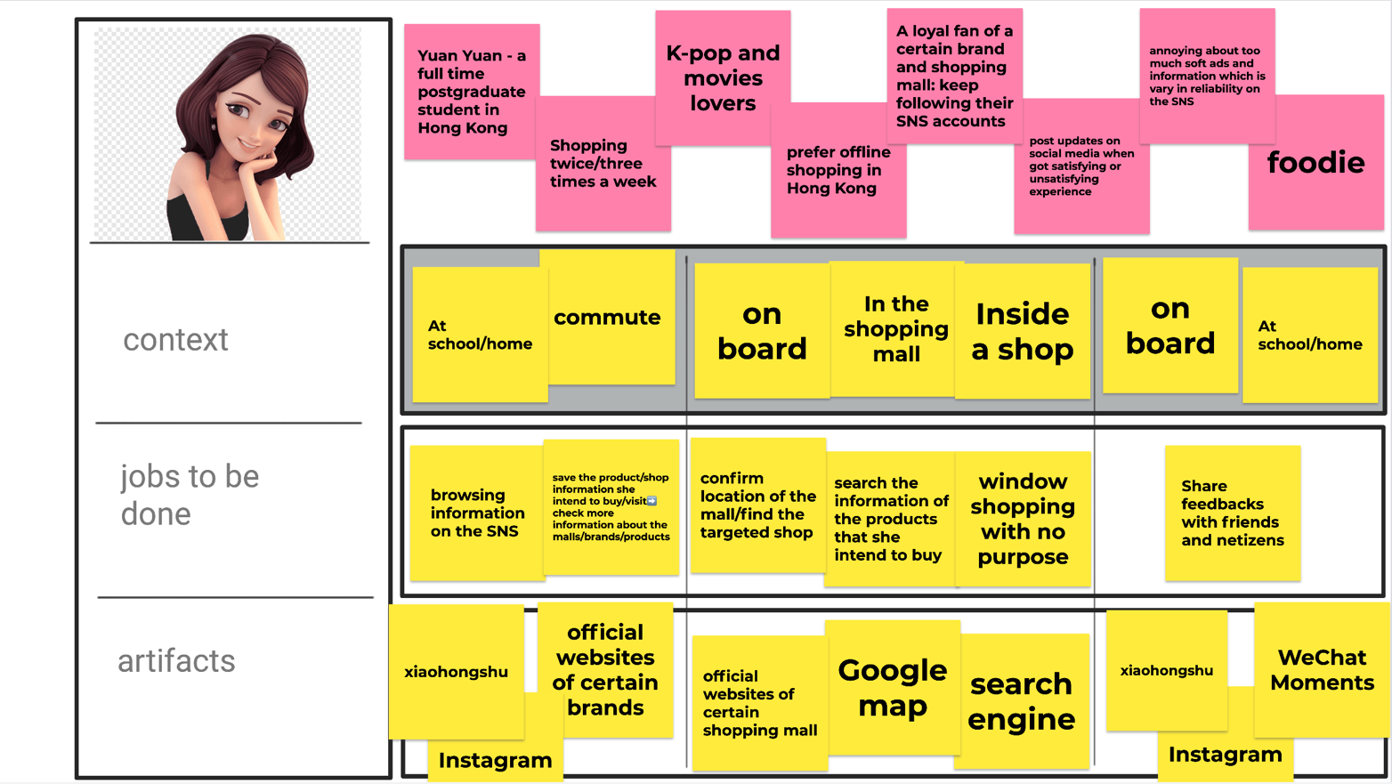

**Problem statement**

How might we make a personalized customer (who) address the problem of acquiring, sharing the timely shopping information and finding the certain shopping place that he/she intended to go in an integrated website with moderate amount of ads (what) to achieve the goal of buying favorite products and having a great shopping time (why)?

**Story map**

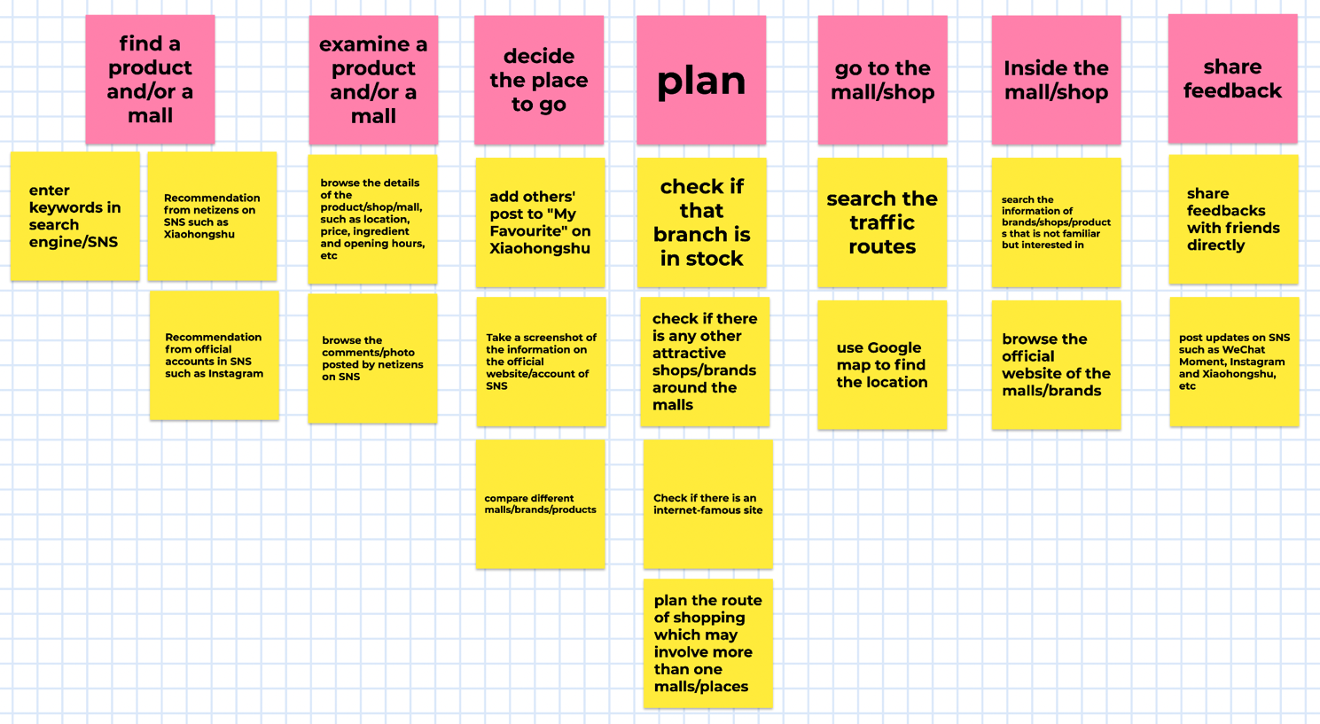

**Open card sort**

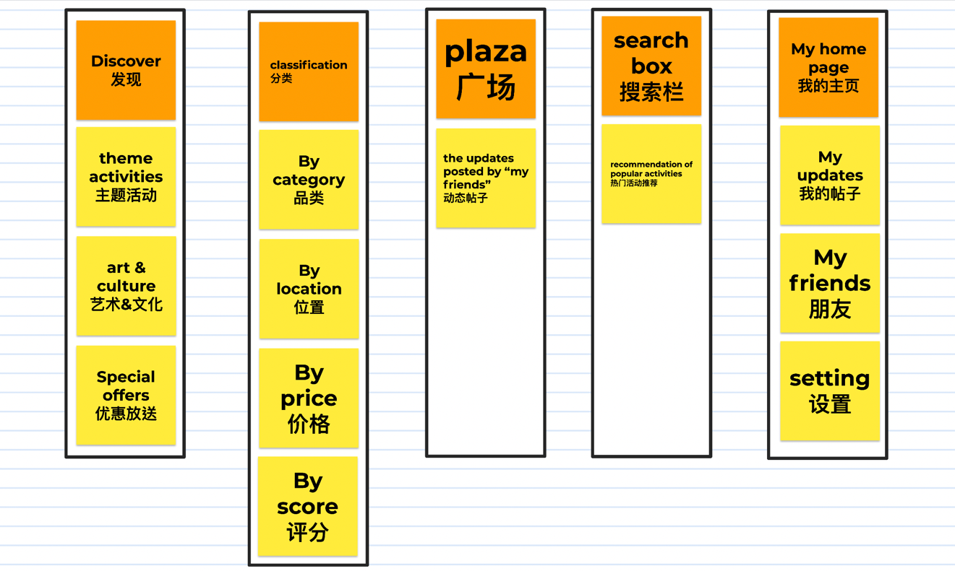

**Position map**

